**Steady-state Lumped Parameter Analysis**

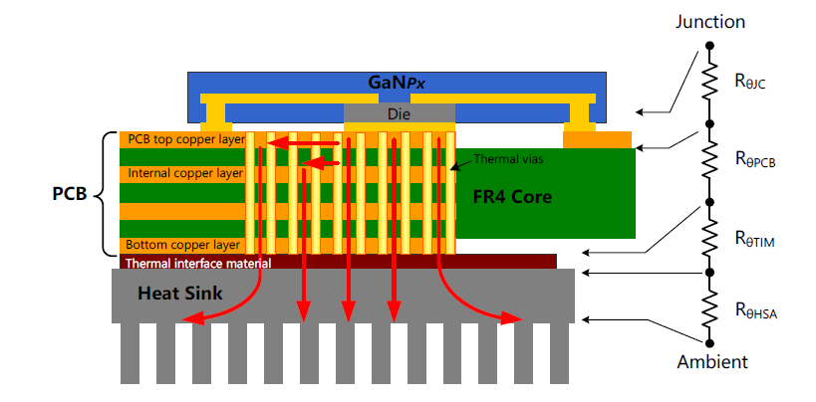

* 123 Thermal via (0.3mm diameter) , 6 Layer PCB, Rjc= 0.5 Ω , Rcpb= 4.5Ω(1.6mm & 6 layer), RTIM = 1.5 Ω

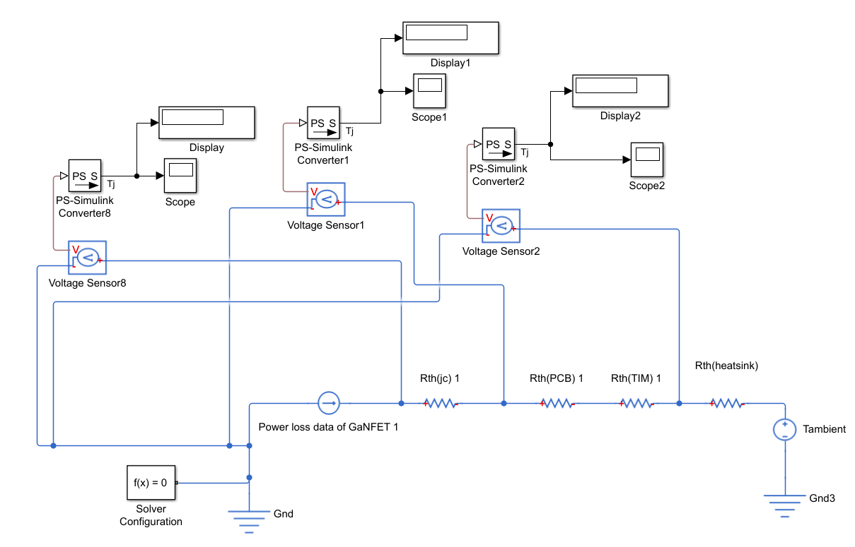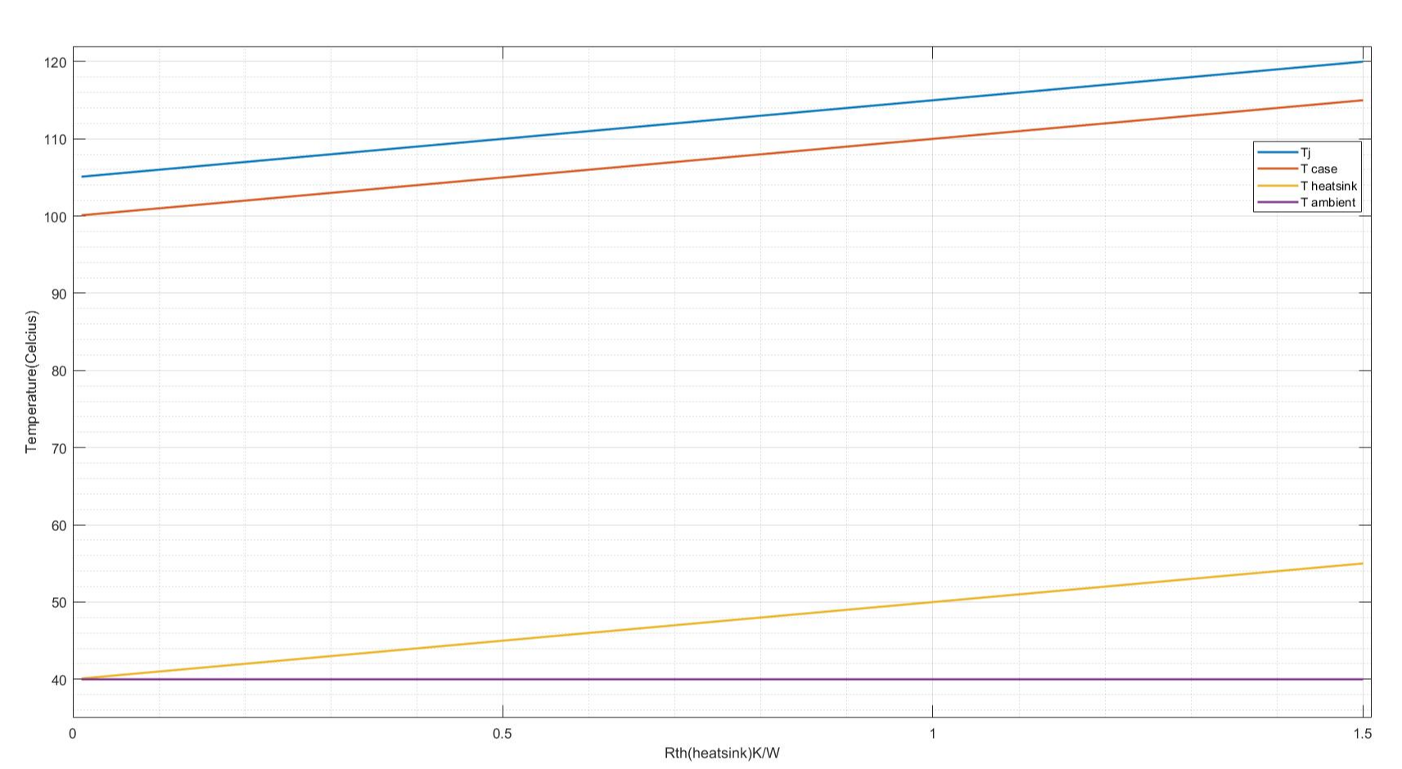

<https://www.myheatsinks.com/calculate/thermal-resistance-plate-fin/>

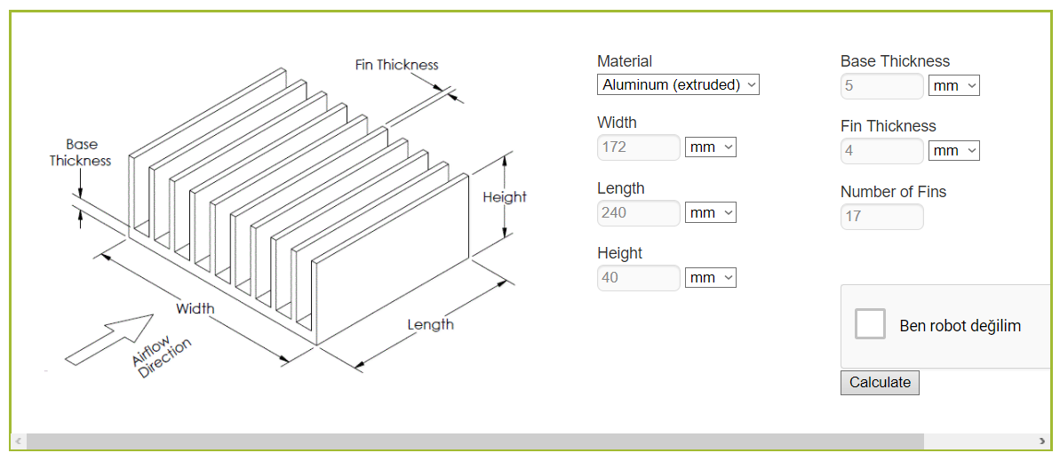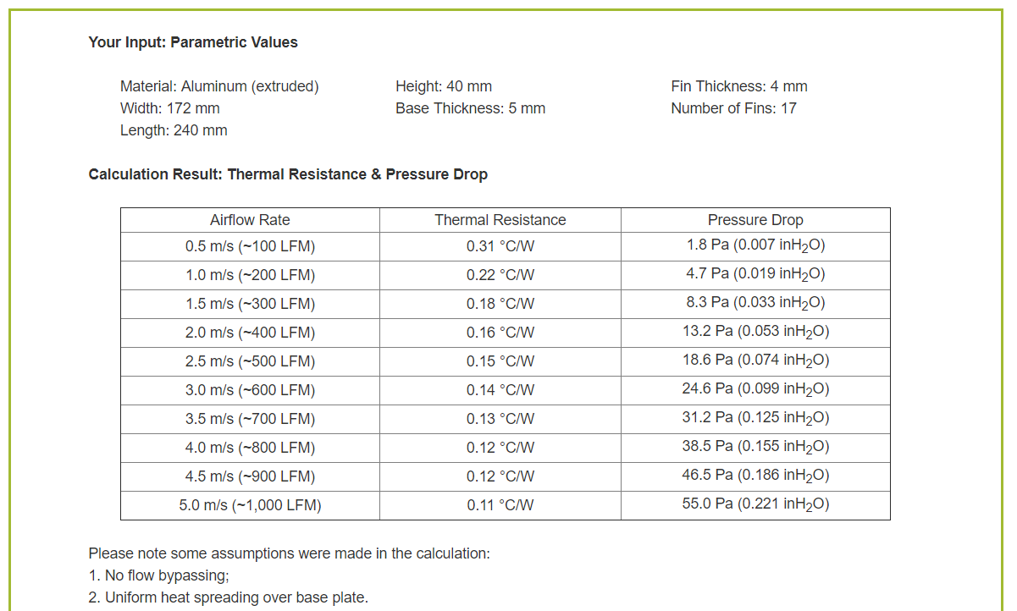

* The results changes between 0.25 - 0.4 ℃/W

**FEA Analysis (Steady State)**

If you think that GanFET is a black box with 0.5 Rjc ;

* L is the thickness (m) (thickness of the package and the thermal pad);
* A is the effective contact area (m2) (Area of the thermal pad) ;
* k is the conductivity of the box (W/(m*K))



* For the most accurate Heat convection coefficients CFD analysis required.

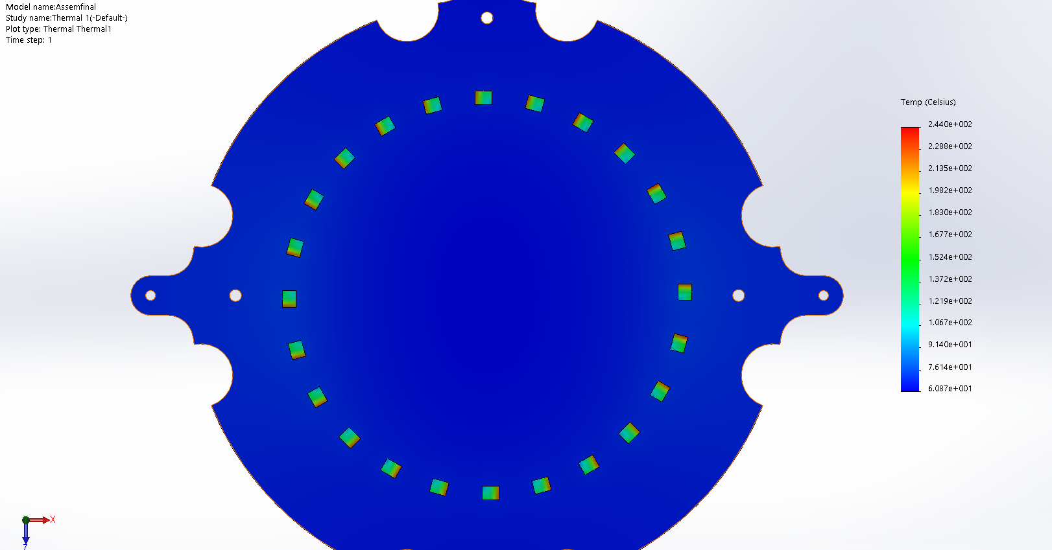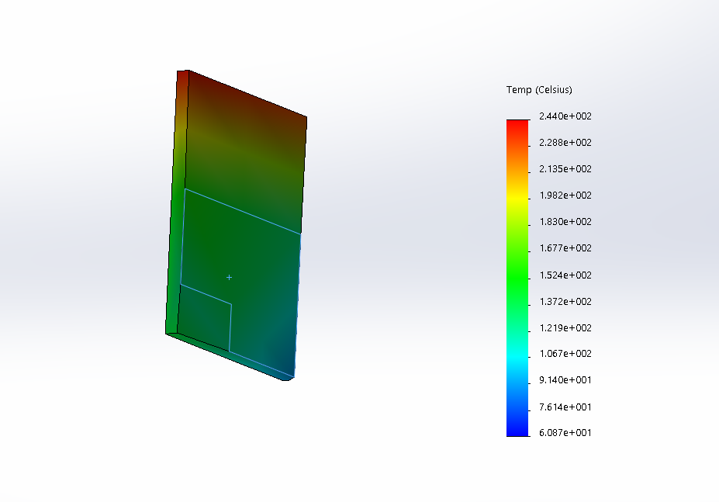

3D Design Engineers are divided into 2 groups;

* MCAD Design engineer (Mechanical)
* ECAD Design Engineer (Electronic)
* These engineers share the common file that is in IDF, EMN or STEP format.
* Each format has different features. (Based on the PCB layout and holes)
* IDF is the most common.

**Following weeks;**

* **FEA Transient Analysis**